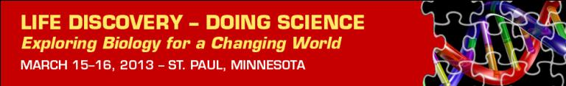
Inaugural Education Conference
Early Bird Registration through Dec. 15  20 left days for Early Bird Registration rates  This conference will highlight the leading science, curriculum design and implementation and data exploration in a research-rich biology education for grades 9-16.  - Discover the science of life in a changing world  - Swap ideas for a robust biology classroom  - Build partnerships with scientists and educators  - Explore digital resources and new technologies  http://www.esa.org/ldc/registration/  NEW! Earn Continuing Education Units  We are excited to offer conference attendees the opportunity to earn one Continuing Education Unit (CEU) for participation in the conference.  For more information: http://www.esa.org/ldc/ceu/ |  | March 15 – 16, 2013  St. Paul, Minnesota  www.esa.org/ldc
 |  | Conference Partners
 |  | 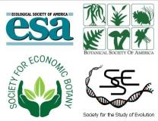
Keynote Speakers and Panels  The LDC Conference will have Keynote speaker and panels, to address pressing issues in Biology Education:  Building Partnerships with Scientists & Educators  Digital Resources and Learning for the Future  Building Pathways and Partnerships between K12 and College  Science of Life in a Changing World  For more information: http://www.esa.org/ldc/program/agenda/  Workshops  View the descriptions and schedule of the six hands-on workshops, available to all conference attendees.  Short Presentations  View descriptions of the short presentations, available to all conference attendees. Presentations are 20 minutes followed by 20 minutes of Q&A.  Fieldtrips  Take part in a field trip to the Raptor Center, at the University of Minnesota |  | Conference Sponsors
 
SimBio
 |  | Questions?
Contact:
Andrea McMillen
andrea@esa.org
(202) 833-8773 x 236
Many thanks our Conference Collaborators
who promote the conference to their professional networks:

Animal Behavior Society  American Institute of Biological Sciences (AIBS)  BEACON Center for the Study of Evolution in Action  Center for Excellence in Education (CEE)  Ecological Research as Education Network (EREN) | National Center for Ecological Analysis and Synthesis  National Education Association (NEA)  National Evolutionary Synthesis Center (NESCent)  National Socio-Environmental Synthesis Center  Virginia Association of Science Teachers

